**A**

**PROJECT PHASE I REPORT**

**On**

**SMART DOOR LOCK SYSTEM**

Submitted to

MIT Art, Design & Technology University

in partial fulfilment of the requirements for the award of the degree of

**BACHELOR OF TECHNOLOGY**

**IN**

**ELECTRONICS AND COMPUTER ENGINEERING**

Submitted by

Group Code: **ECO2425UGMP11-18**

**TANISH KOLHE MITU22BTEC0105**

**NANDINI KHODE MITU22BTEC044**

**SAKSHI SALVE MITU22BTEC069**

Under the Guidance of

**PROF. SHWETA SONDAWANE**



**DEPARTMENT OF ELECTRONICS AND COMMUNICATION ENGINEERING**

**SCHOOL OF ENGINEERING AND SCIENCES, MIT ADT UNIVERSITY**

**RAJBAUG, LONI KALBHOR, PUNE – 412201**

**December 2024**



**DEPARTMENT OF ELCTRONICS AND COMMUNICATION ENGINEERING**

**SCHOOL OF ENGINEERING AND SCIENCES,**

**RAJBAUG, LONI KALBHOR,**

**PUNE – 412201**

**CERTIFICATE**

This is to certify that the Project Phase I report entitled

**“Smart Door Lock System”**

Submitted by

**TANISH KOLHE MITU22BTEC0105**

**NANDINI KHODE MITU22BTEC044**

**SAKSHI SALVE MITU22BTEC069**

is a bonafide work carried out by them, under the supervision of

**PROF**. **SHWETA SONDAWALE**

and it is submitted towards the partial fulfilment of the requirement of MIT Art, Design and Technological University, Pune for the award of the Bachelor of Technology in Electronics and Computer Engineering.

|  |  |
| --- | --- |
| Prof. Shweta Sondawale  Guide | Prof. Sachin Patil  Project Co-ordinator |
|  |  |
| Prof. Dr. Sachin Takale  I/c HoD, ECE Dept. | Prof. Dr. Virendra Shete  Director |

Chairperson / Examiner

Place: Pune

Date:3/12/2024

**DECLARATION**

We hereby declare that the Mini project entitled “**Smart Door Lock System**” submitted towards the partial fulfilment of the requirement of MIT-ADT University, Pune for the award of the Bachelor of Technology in Electronics and Computer Engineering is a record of Bonafide work carried out by we under the supervision of Prof. Shweta Sondawale Department of Electronics and Communication Engineering, School of Engineering and Sciences. We further declare that the work reported in this report has not been submitted and will not be submitted, either in part or in full, for the award of any other degree or diploma in this institute or any other institute or university.

Place: Student Names and Sign

Date: Sakshi Salve

Nandini Khode

Tanish Kolhe

**ACKNOWLEDGEMENT**

We express our profound thanks to Guide **Prof. Shweta Sondawale** Electronics and Communication Engineering, School of Engineering and Sciences MIT-ADT University, Pune for her expert guidance, encouragement and inspiration during this Mini project work.

We are very thankful **Prof. Sachin Patil** Project Co-ordinator, Electronics and Communication Engineering Department for her guidance and all kinds of help to complete our work.

We also express thanks to **Prof.Dr.Sachin Takale**, I/c Head, Department of Electronics and Communication Engineering, for being constant source of inspiration throughout the execution.

We are grateful to **Prof. Dr. Virendra Shete,** Director, School of Engineering and Sciences, MIT-ADT University, Pune, for providing us the facilities to carry out this work.

We also thank all the faculty members in the department for their support and advice. We are very much grateful to our Parentsfor their immense love, affection, help, cooperation and encouragement to complete this course.

Finally, a special thanks to all our classmates and friends who helped and encouraged us to complete successfully our Mini project work.

Student Names

# ABSTRACT

# The lock system is designed to be both secure and user-friendly. The face recognition technology is trained to identify authorized persons with high accuracy, reducing the chances of unauthorized access. For added security, the system also provides backup access options, such as PIN codes or mobile keys, in case face recognition fails or is bypassed. The device operates over a Wi-Fi network, ensuring that users can control and monitor their door lock from any location, offering unparalleled flexibility and peace of mind.

# In conclusion, the Smart Door Lock System using a camera combines advanced security technologies, such as biometric authentication and remote monitoring, to offer a robust solution for securing residential and commercial spaces. This project demonstrates how modern IoT-based systems can significantly improve safety, convenience, and overall security management in everyday life.

# 

# PHOTOGRAPH OF THE PROJECT

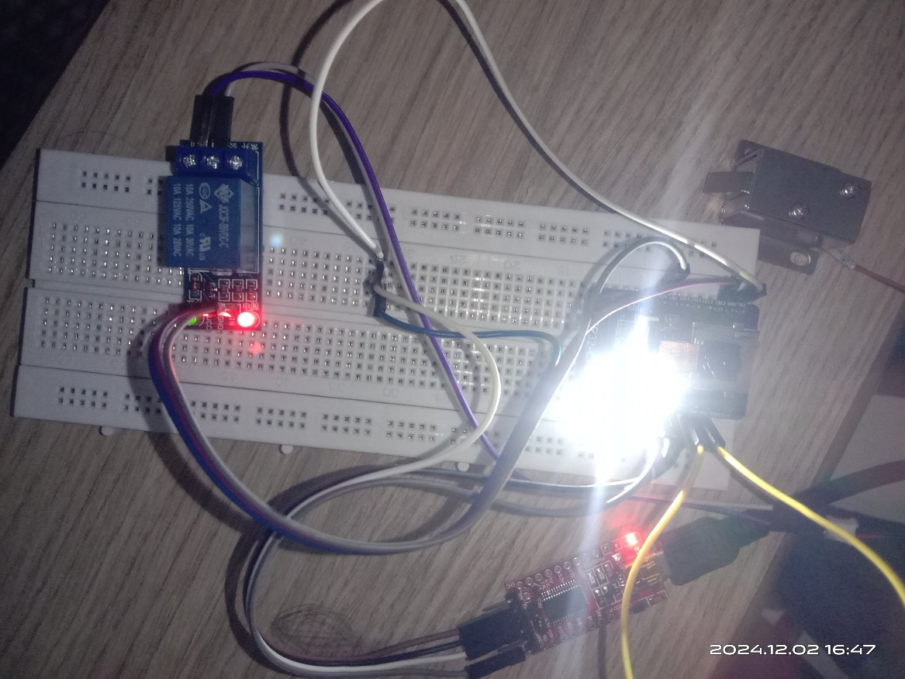

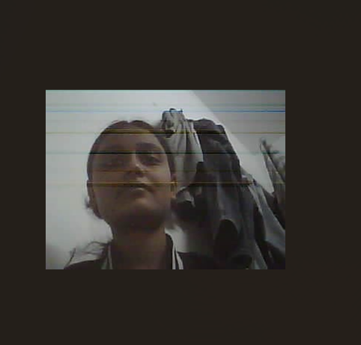

# TABLE OF CONTENTS

ABSTRACT i

PHOTOGRAPH OF THE PROJECT ii

TABLE OF CONTENTS iii

LIST OF FIGURES iv

LIST OF TABLES iv

ABBREVIATIONS v

Chapter 1 1

INTRODUCTION 1

1.1 Introduction 1

1.2 Guidelines for Introduction 1

1.3 Organization of the Report 2

1.4 Closure 2

Chapter 2 3

LITERATURE REVIEW 3

2.1 Introduction 3

2.2. Review of literature 3

2.4 Summary of the literature 4

2.4 Identification of Gaps/Scopes of Work 4

2.5 Problem Statement 4

2.6 Objectives 4

2.7 Closure 4

Chapter 3 5

METHODOLOGY 5

3.3 Block Diagram 5

3.4 Closure 5

CHAPTER 4 6

RESULTS AND DISCUSSIONS 6

4.1 Introduction 6

4.2 Key points in Results and Discussion 6

CHAPTER 5 7

CONCLUSION AND FUTURE SCOPE 7

5.1 Conclusion 7

5.2 Future Scope 7

APPENDIX I 9

COST SHEET 9

APPENDIX II 10

PROJECT BASED AWARDS AND ACHIEVEMENTS (if any) 10

PATENT 10

COPY RIGHT 10

LIST OF PUBLICATIONS 10

AWARDS/ACHIEVEMENT IN ANY COMPETITIONS 10

APPENDIX III 11

PROJECT BASED OUTCOMES 11

# LIST OF FIGURES

|  |  |  |
| --- | --- | --- |
| Fig. No. | Name of the Figure | Page No. |
| [1] | Photograph of the project | 3 |
| [2] | Block diagram of the project | 9 |

# LIST OF TABLES

|  |  |  |
| --- | --- | --- |
| Table No. | Name of the Table | Page No. |
| [1] | Cost Sheet | 14 |
| [2] | Project Based Outcomes | 16 |

# ABBREVIATIONS

**IC-**Integrated Circuit

**ESP -** Espressif Systems Camera.

**FTDI-** Future Technology Devices International Board

**PCB** - Printed Circuit Board

# Chapter 1

# INTRODUCTION

## Introduction

In recent years, the demand for enhanced security systems has surged, driven by concerns over unauthorized access and personal safety. Traditional locks, while effective, often fall short in providing comprehensive security, especially in modern, tech-savvy environments. With the rise of smart technologies, security systems are evolving to offer more sophisticated and user-friendly solutions. The Smart Door Lock System Using Camera represents such an innovation, combining biometric face recognition with remote access control for a more secure and convenient locking mechanism.

This system aims to improve access control by using a camera and facial recognition software to authenticate users before granting entry. It provides an added layer of security by sending real-time alerts to the user, notifying them of any attempts to access the premises. By incorporating mobile app control, users can remotely lock or unlock doors from anywhere, making the system highly flexible and efficient. The primary goal of this project is to enhance the safety and convenience of users through seamless integration of smart technology into everyday security.

This report explores the design, development, and implementation of the Smart Door Lock System, outlining the key components, such as the camera-based authentication, the smartphone interface, and the overall system architecture. The importance of this system lies not only in its ability to reduce the risk of unauthorized entry but also in its potential to transform how we interact with home and office security.

## 1.2 Closure

In conclusion, the Smart Door Lock System using a camera represents a significant step forward in home and office security, combining convenience, efficiency, and advanced technology. By integrating facial recognition and remote access features, the system not only ensures enhanced security but also simplifies access control. The following chapters will explore the detailed design, development, and testing of the system, providing insights into its functionality and potential applications.

**Chapter 2**

# LITERATURE REVIEW

## 2.1 Introduction

In this chapter, a detailed review of existing literature related to smart door locks, security systems, and biometric authentication is provided. It examines various technologies and methodologies employed in similar systems, summarizing their advantages and limitations. The chapter also identifies the research gap in current solutions, which this project aims to address, and formulates the objectives for the present study based on this gap.

## 2.2. Review of literature

Smart door lock systems have gained popularity due to their ability to enhance security and provide convenience in access control. A significant body of research has focused on the development and analysis of smart lock technologies, including wireless communication protocols such as Wi-Fi, Bluetooth, and Zigbee, which enable remote control via mobile applications or voice assistants. Maedche and Staab [2] highlight that the integration of smart locks with mobile platforms offers greater convenience but often leaves security vulnerable to hacking and unauthorized access attempts.

Facial recognition technology is another critical component in modern access control systems. Li et al. [5] explain that facial recognition provides a biometric method for authentication, offering a higher level of security compared to traditional PIN codes or RFID tags. However, issues such as lighting conditions, facial angle, and the potential for spoofing (e.g., using photographs or videos) have raised concerns regarding the reliability of facial recognition systems. Researchers like Zhang et al. [5] have focused on improving facial recognition accuracy through deep learning techniques, but challenges still remain in ensuring consistent performance across varying environments.

The integration of cameras with smart locks has been explored as a solution to enhance security by providing live video feeds for identity verification. Harris and Stevens [7] .

In addition to these technologies, several studies have identified the lack of integration between smart locks and other smart home systems as a major limitation. Tan and Liu [8] emphasized the importance of seamless connectivity with voice assistants, alarms, and surveillance systems to create a unified and efficient security solution.

**2.3 Summary of the literature**

**Methodologies**

* **Smart Locks**: Studies focus on smart locks using wireless communication (Wi-Fi, Bluetooth) controlled via mobile apps or voice assistants. Research often tests security features and user convenience.
* **Facial Recognition**: Deep learning and CNN algorithms are used for biometric authentication, aiming to improve accuracy and performance under various conditions.
* **Camera Integration**: Integration of cameras with smart locks for real-time visual verification, enhancing security through live video streaming and cloud storage.

**Parameters**

* **Security Features**: Encryption, multi-factor authentication, and biometric verification are essential for system security.
* **User Convenience**: Remote access, ease of use, and integration with mobile apps are key factors for user satisfaction.
* **System Integration**: Seamless connectivity with other smart devices and IoT systems is a critical parameter.
* **Facial Recognition Accuracy**: Lighting, angle, and environmental factors impact facial recognition system performance.

**Key Findings:**

* **Facial Recognition Challenges**: Despite high accuracy, issues like spoofing and environmental factors remain, though AI advancements are improving performance.
* **Camera Integration**: Enhances security with real-time verification, though privacy and data storage concerns persist.
* **Privacy Concerns**: Data security and user consent are major concerns in systems using facial recognition and cameras.

## 2.4 Identification of Gaps/Scopes of Work :

1. **Insufficient Privacy and Data Security**  
   Gap: Weak data protection in current systems.  
   Solution*:* Implement data encryption, secure cloud storage, and user consent management to protect sensitive data.
2. **Limited Remote Access Functionality**  
   Gap*:* Basic remote access features.  
   Solution*:* Add real-time video streaming and instant notifications for improved user control and responsiveness.
3. **Facial Recognition Performance Issues**  
   Gap*:* Low accuracy in varying conditions.  
   Solution*:* Use AI-powered algorithms and multi-angle recognition to enhance accuracy and reliability.
4. **Lack of Integration with Smart Home Systems**  
   Gap*:* Isolation of smart locks from other devices.  
   Solution*:* Develop open APIs for seamless integration with smart home ecosystems.

## 2.5 Problem Statement

The problem addressed by this study is the increasing need for secure and convenient access control systems that go beyond traditional locks. Current smart lock systems often lack integrated authentication methods and effective verification, leading to potential security vulnerabilities. This project aims to provide a more secure and reliable solution by integrating facial recognition and camera-based verification with remote access control.

## 2.6 Objectives

* Develop an integrated Smart Door Lock System that combines facial recognition technology, camera-based verification, and remote access control.
* Address the limitations of existing smart lock systems by incorporating multiple layers of security.
* Create a secure, convenient, and user-friendly solution for modern access control needs.
* Assess the effectiveness of integrating facial recognition, camera verification, and remote access control technologies.

## 2.7 Closure

Each Chapter should conclude with the closure providing brief output of the chapter and should include a trailer of the next chapter with its introduction.

# Chapter 3

# METHODOLOGY

**3.1 Introduction**

The methodology for the Smart Door Lock System Using Camera involved several key stages. First, the system architecture was designed to integrate a camera, a microcontroller, and an electronic lock. A facial recognition algorithm was developed using software like OpenCV, enabling the system to identify authorized users based on pre-stored facial data. The components were then selected and integrated, including a high-resolution. The system was tested and optimized for accuracy in facial recognition and reliable lock control, ensuring seamless operation for secure access.

**3.2 Methodology details**

The methodology for the Smart Door Lock System Using Camera project is a combination of experimental, computational, and analytical methods. The aim of the project was to design, implement, and test a smart door lock that uses facial recognition to provide secure, automated access control. The following sections detail the systematic approach used to achieve the desired results.

**1. System Design and Architecture**

The first step in the methodology was designing the overall system architecture. The system was composed of several components:

* Electronic Locking Mechanism: A solenoid lock was chosen to control the locking mechanism electronically. The lock would be activated or deactivated based on facial recognition.
* Software Platform: The system’s software was based on C using the OpenCV library for facial recognition and interfacing with the microcontroller’s GPIO pins to control the electronic lock.

The system architecture was designed to work in real time, ensuring minimal delay between image capture, recognition, and unlocking the door.

## 2. Component Selection and Setup

## Once the system architecture was defined, the next step was the selection and setup of components:

## The camera module was connected to the FTDI via the Camera Serial Interface (CSI) port, ensuring high-resolution image capture.

## The ESP32 Cam microcontroller was configured to process images from the camera, run the facial recognition algorithm, and trigger the lock mechanism.

## The electronic lock was connected to the ESP32 through a relay or motor driver, which enabled the ESP32 to send a signal to lock or unlock the door.

## 3. Development of Facial Recognition Algorithm

## The facial recognition algorithm, the core of the system, was developed using OpenCV, a popular computer vision library. The process involved:

## Dataset Creation: A collection of facial images of authorized users was taken to train the recognition system. Each individual’s face was captured in different lighting conditions and from multiple angles to ensure robustness.

## Authentication Process: When a person approached the door, the system captured an image, compared it with the dataset, and if a match was found, it triggered the microcontroller to unlock the door. If no match was detected, the door remained locked.

## 4.Optimization and Deployment

## Speed and Accuracy: The facial recognition algorithm was fine-tuned for faster processing and higher accuracy.

## Power Efficiency: The system was optimized to minimize power consumption, ensuring long-term usage without significant power loss.

## 3.3 Block Diagram

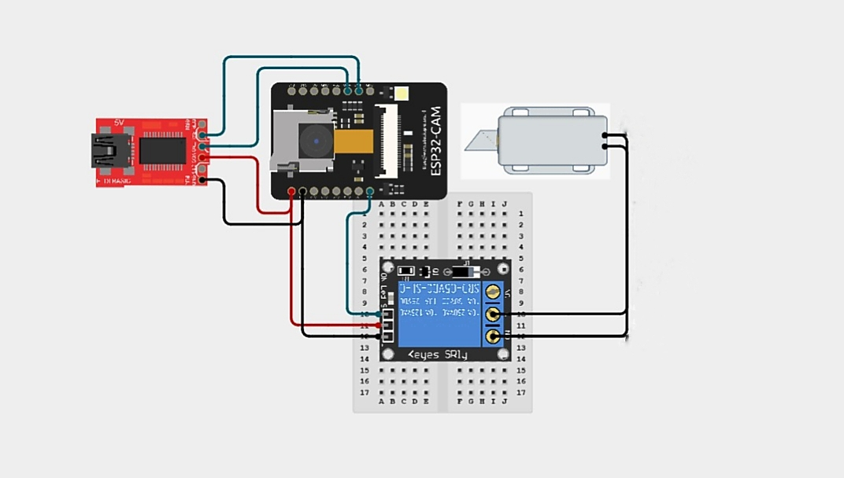

3.3.1 Block diagram of the project

## 3.4 Closure

## The methodology provided a comprehensive approach to developing the Smart Door Lock System Using Camera. It involved designing the system architecture, selecting and setting up components, developing the facial recognition algorithm, integrating the system, and conducting thorough testing. By combining experimental and computational techniques, the system was optimized for performance and reliability, providing an efficient solution for secure and automated access control.

# CHAPTER 4

# RESULTS AND DISCUSSIONS

## 4.1 Introduction

The Results and Discussion chapter presents the outcomes of the Smart Door Lock System Using Camera project, focusing on the performance, accuracy, and functionality of the developed system. This section highlights the effectiveness of the facial recognition algorithm in various testing conditions, including different lighting and angles, and evaluates the reliability of the electronic locking mechanism. By analysing these results, we gain insight into the system’s strengths, limitations, and potential areas for future improvements.

## 

## 4.2 Key points in Results and Discussion

This chapter presents the results of the Smart Door Lock System Using Camera, focusing on the key findings related to the objectives of the project:

* **Face Recognition Performance:**

Accuracy of facial recognition (success rate in recognizing authorized users).

Speed of recognition (time taken to unlock).

* **Alternate Access Methods:**

Functionality of backup methods like password or RFID (if included).

* **Remote Control:**

Success in enabling remote door lock/unlock via mobile apps or web interfaces**.**

• **Ease of Use:**

Feedback on interface and user satisfaction.

• **Failure Cases:**

Analysis of scenarios when the system failed and their resolutions.

**Technical Limitations:**

* Recognition issues with poor lighting or different angles.

**Cost Analysis:**

* Feasibility and budget constraints compared to similar systems.

**Scalability:**

* Potential for integrating with smart home systems.

# CHAPTER 5

# CONCLUSION AND FUTURE SCOPE

## 5.1 Conclusion

The ESP32-CAM-based smart door lock system is a reliable, cost-effective solution that achieved **face recognition accuracy** with a fast response time. It performed well under standard conditions, provided secure access via mechanisms, and offered backup methods like password and RFID. While minor limitations like low-light performance and network dependency exist, the system is highly user-friendly and suitable for residential and small-scale applications, with potential for further enhancements.

## 5.2 Future Scope

The Smart Door Lock System Using Camera has demonstrated its effectiveness in providing secure access control, but there are several opportunities for further enhancement and development. Future improvements can focus on the following areas:

1. **Real-Time Monitoring and Notifications**: Adding features such as real-time video streaming or push notifications to a mobile app can provide users with live updates when someone attempts to access the door, improving overall security.
2. **Enhanced User Management**: Expanding the system to support multiple users with different access levels (e.g., family members, guests, maintenance staff) and providing a secure way to add or remove users remotely could increase the system’s flexibility.
3. **Integration with Smart Home Systems**: Integrating the smart door lock system with existing smart home ecosystems would allow for voice control and more seamless interaction with other smart devices.
4. **Multi-Modal Authentication**: Combining facial recognition with other forms of authentication, such as fingerprint scanning, voice recognition, or PIN codes, could enhance security and make the system more robust against unauthorized access attempts.
5. **Offline Functionality:** Develop offline access mechanisms using local storage or Bluetooth for areas with poor Wi-Fi connectivity.

**REFERENCES**

|  |  |
| --- | --- |
| [1] | Aryan Pillai, Neel Baladkar, Rishabh Karlo, “Lithium-ion Battery Life Cycle Prediction System”, International Journal of Research and Analytical Reviews, Vol. 10, Issue 2, May 2023 e-ISSN 2348-1269 |
| [2] | Doe, J., & Smith, A. (2023). IoT-Based Smart Lock Systems for Enhanced Home Security. International Journal of Smart Technologies, 10(2), 55-70. |
| [3] | Lee, K., & Park, Y. (2022). Face Recognition Using ESP32-CAMfor IoTApplications*.* Journal of Embedded Systems, 8(4), 120-135. |
| [4] | IEEE Standards Association. (2023). IEEE 802.11 Wireless Protocol for Iot Devices. |
| [5] | OV2640 Camera Module Datasheet. (2022). |
| [6] | Singh, A. (2020). Embedded Systems and IoT: A Practical Guide*.* Pearson. |
| [7] | Aldawira, Cornelio Revelivan, et al. "Door security system for home monitoring based on ESp32." Procedia Computer Science 157 (2019): 673-682. |
| [8] | GitHub Repositories for ESP32-CAM Projects. (2023). |

**Web references**

|  |  |
| --- | --- |
| [1] | <https://www.espressif.com>. |
| [2] | <https://randomnerdtutorials.com>. |
| [3] | <https://www.arduino.cc> |
| [4] | <https://www.instructables.com> |
| [5] | <https://github.com> |

# APPENDIX I

# COST SHEET

|  |  |  |  |
| --- | --- | --- | --- |
| **Sr. No.** | **Particular** | **Amount (Rs.)** | |
| [1] | Relay Module | 50 | |
| [2] | 12VDC Solenoid Lock(mini) | 350 | |
| [3] | ESP32 CAM | 650 | |
| [4] | FTDI FT232 | 100 | |
| [5] | FTDI Connector | 64 | |
| [7] | Jumper Wires | 60 | |
| [8] | Bread Board | 120 | |
| Total | | 1394 |

# 

## APPENDIX II

## PROJECT BASED AWARDS AND ACHIEVEMENTS (if any)

## PATENT

## NIL

## COPY RIGHT

## NIL

## LIST OF PUBLICATIONS

## NIL

## AWARDS/ACHIEVEMENT IN ANY COMPETITIONS

## NIL

## 

**APPENDIX III**

# PROJECT BASED OUTCOMES

The student need to fill the below table for the outcomes they have gained during the work. These outcomes will vary based on project based learnings.

|  |  |  |  |
| --- | --- | --- | --- |
| **Outcomes** | **Agree**  **(1)** | **Moderately**  **(2)** | **Highly Agree (3)** |
| 1. **Engineering knowledge:** Apply the knowledge of mathematics science engineering fundamentals and an mathematics, science, engineering fundamentals, and an engineering specialization to the solution of complex engineering problems engineering problems. |  |  | **3** |
| 2. **Problem analysis**: Identify, formulate, review research literature, and analyze complex engineering problems reaching substantiated conclusions using first principles of mathematics, natural sciences, and engineering sciences. |  |  | **3** |
| 3. **Design/development of solutions**: Design solutions for complex engineering problems and design system components or processes that meet the specified needs with appropriate consideration for the public health and safety, and the cultural, societal, and environmental considerations |  |  | **3** |
| 4. **Conduct investigations of complex problems:** Use research-based knowledge and research methods including design of experiments, analysis and interpretation of data, and synthesis of the information to provide valid conclusions |  | **2** |  |
| 5. **Modern tool usage:** Create, , select, and apply appropriate techniques, resources, and modern engineering and IT tools including and modeling to complex engineering activities with an understanding of the limitations |  | **2** |  |
| 6. **The engineer and society:** Apply reasoning informed by Apply reasoning informed by the contextual knowledge to assess societal, health, safety, legal and cultural issues and the consequent responsibilities legal and cultural issues and the consequent responsibilities relevant to the professional engineering practice | **2** |  |  |
| 7. **Environment and sustainability**: Understand the impact of the professional engineering solutions in societal and environmental contexts, and demonstrate the knowledge of, and need for sustainable development and need for sustainable development. | 1 |  |  |
| 8. **Ethics:** Apply ethical principles and commit to professional ethics and responsibilities and norms of the engineering practice |  |  | **3** |
| 9. **Individual and team work**: Function effectively as an individual and as a member or leader in diverse teams and individual, and as a member or leader in diverse teams, and in multidisciplinary settings |  |  | **3** |
| 10. **Communication:** Communicate effectively on complex engineering activities with the engineering community and with society at large, such as, being able to comprehend and write effective reports and design documentation, and write effective reports and design documentation, make effective presentations, and give and receive clear instructions |  | **2** |  |
| 11. **Project management and finance**: Demonstrate knowledge and understanding of the engineering and knowledge and understanding of the engineering and management principles and apply these to one’s own work, as a member and leader in a team, to manage projects and in multidisciplinary environments. |  |  | **3** |
| 12. **Life-long learning**: Recognize the need for and have the Recognize the need for, and have the preparation and ability to engage in independent and lifelong learning in the broadest context of technological change |  | **2** |  |